Accolite Internal

Setup Guide to HRM Project

Softwares Required:

- Eclipse : Preffered version : Oxygen
- Git Extensions : Software for Version Control (https://github.com/gitextensions/gitextensions/releases)

Steps to get started:

- Install Git and Git Extensions
- Get registered on Git by your Accolite email ID.
- Send out a mail to avi.baraswal@accoliteindia.com for the read and write access to the HRMS project.
- Create a folder structure in the file system with 2 folders: Master and Branch.
- Clone the Git project into your Master folder. This will act as a trunk for reference.
- The link to clone the Project:
https://github.com/accolite/hrms.git
- Create a branch with your name for further development activities.
7.1 Go to the Branch folder directory and create the a branch with your name with dev_<firstName>.

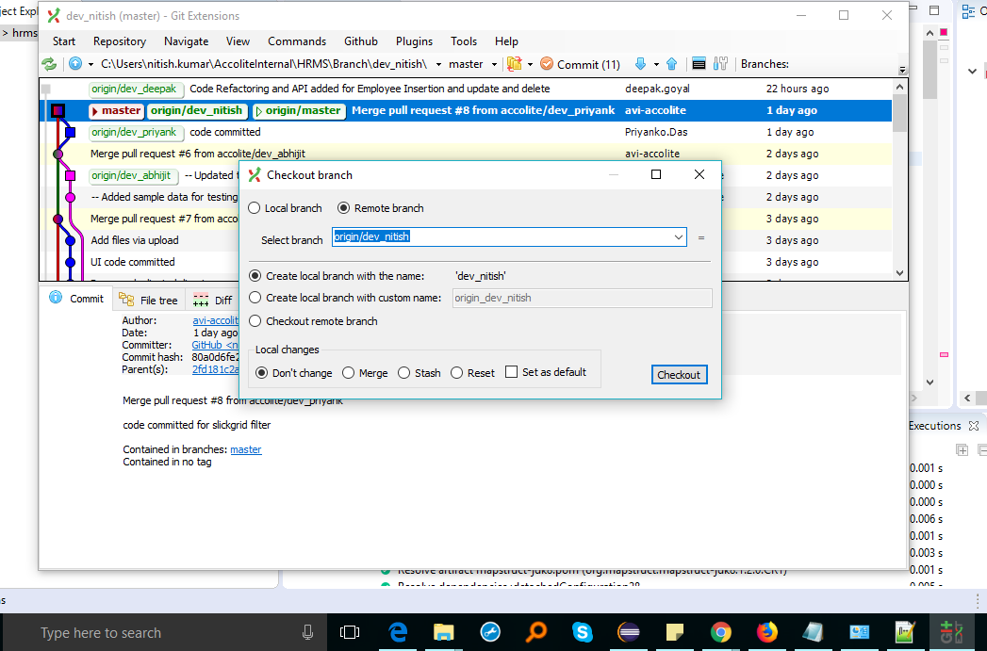

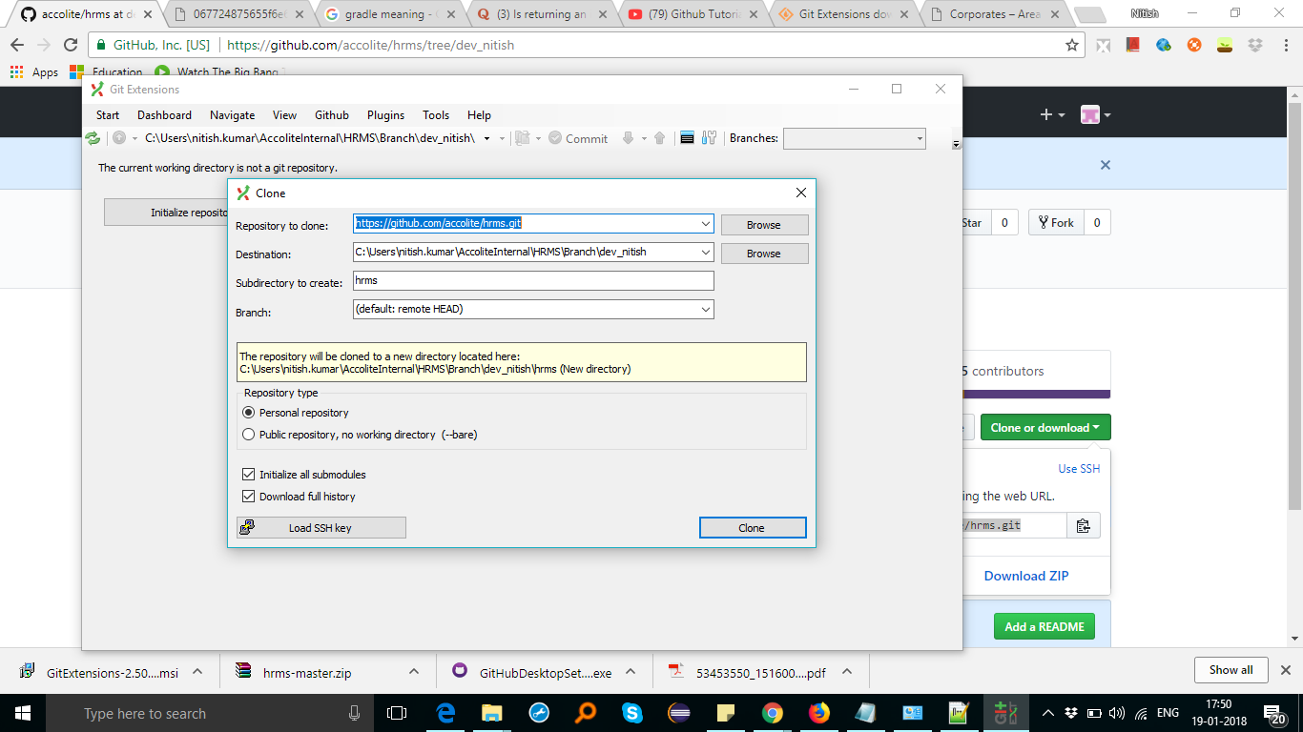
  - Checkour the Branch in your directory:
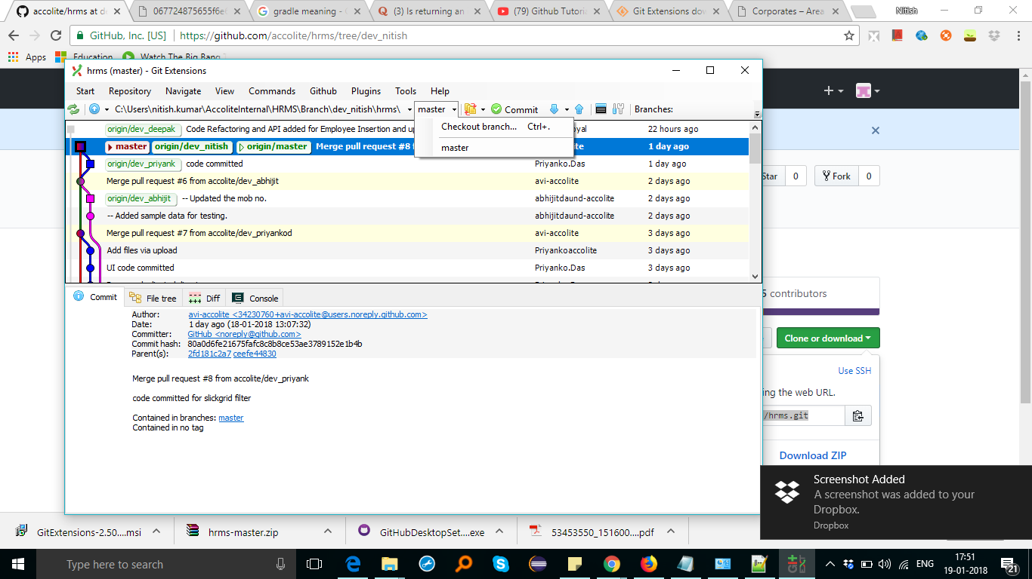

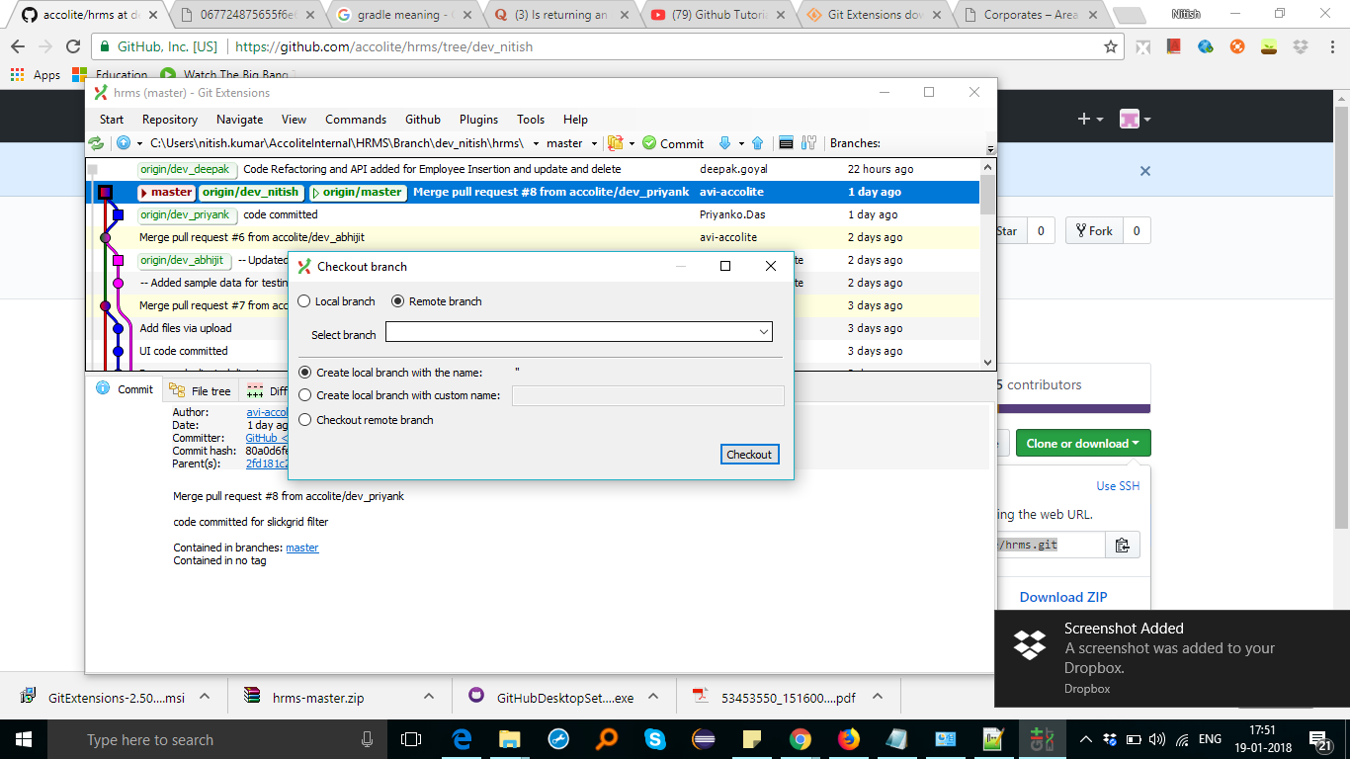

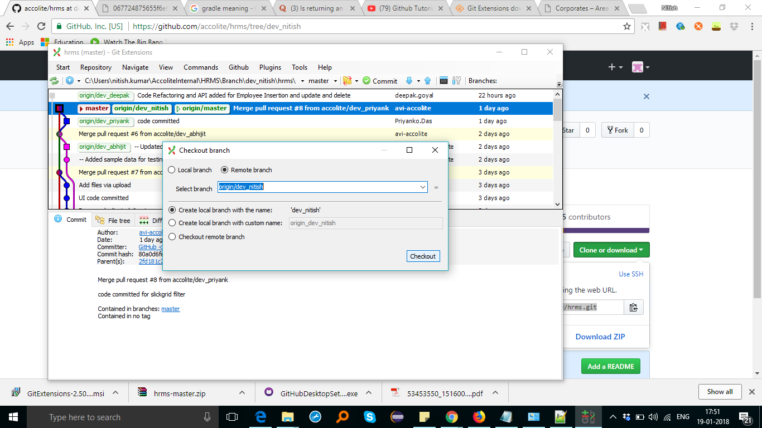
Eclipse Setup:

Import the hrms project as a Gradle Project.

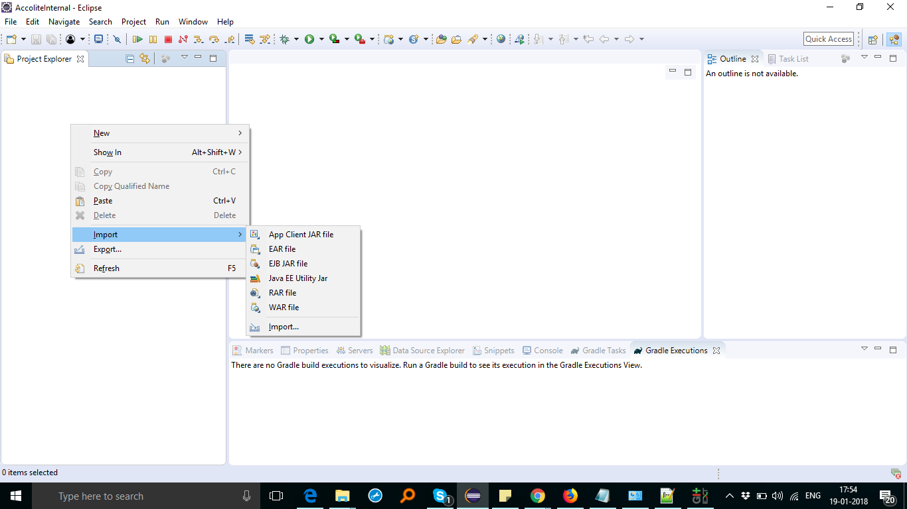

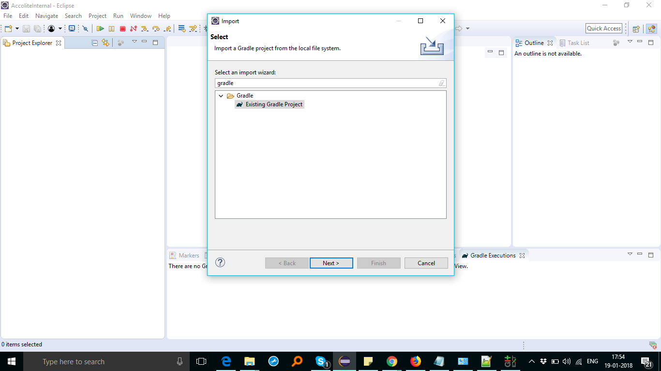

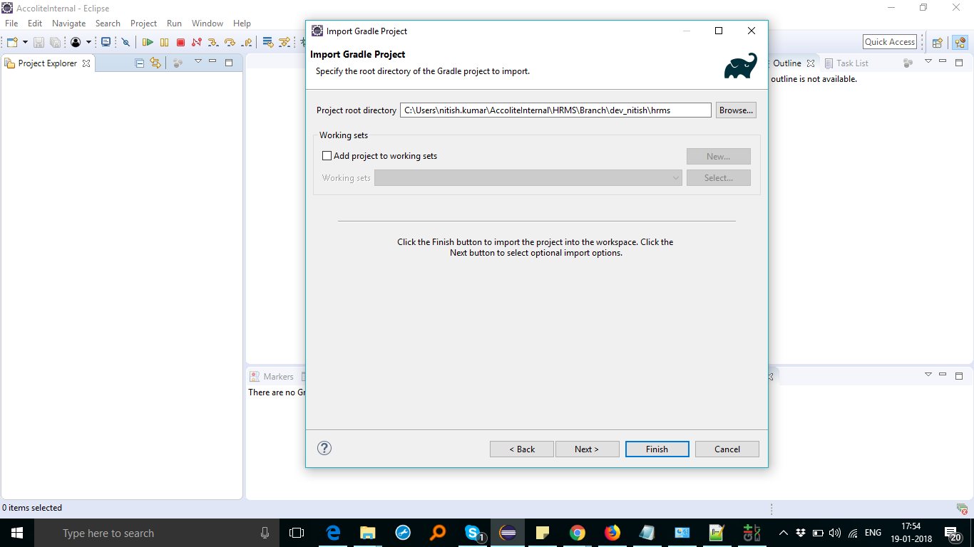

Download all the dependencies:

Right click on the project and refresh the Gradle Project

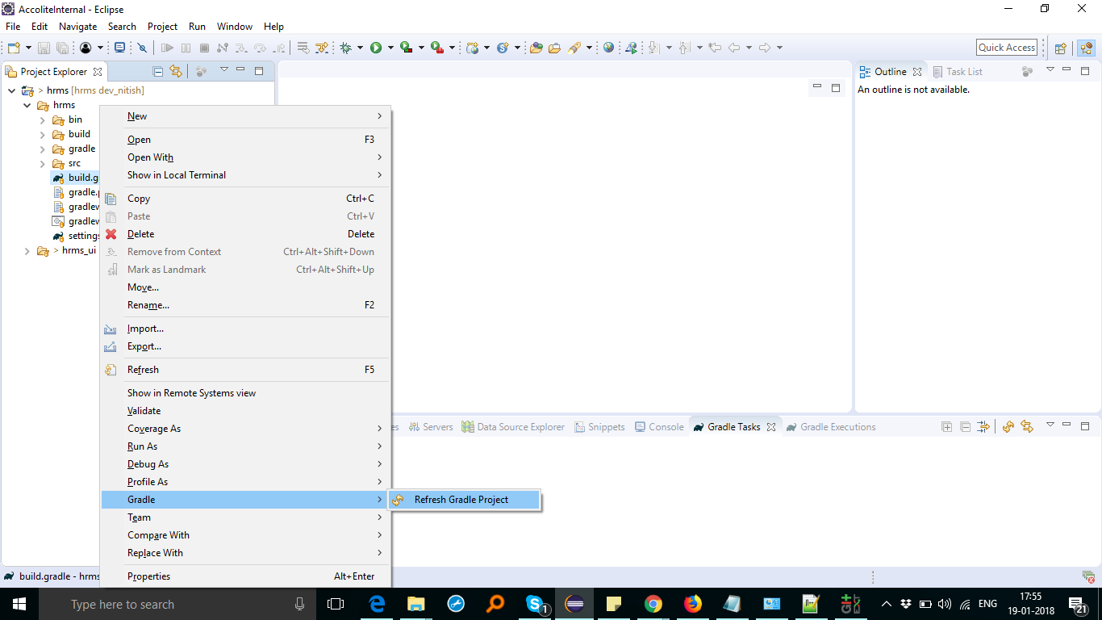

Under the Gradle Tasks view, double click on the build option to build the hrms Project:

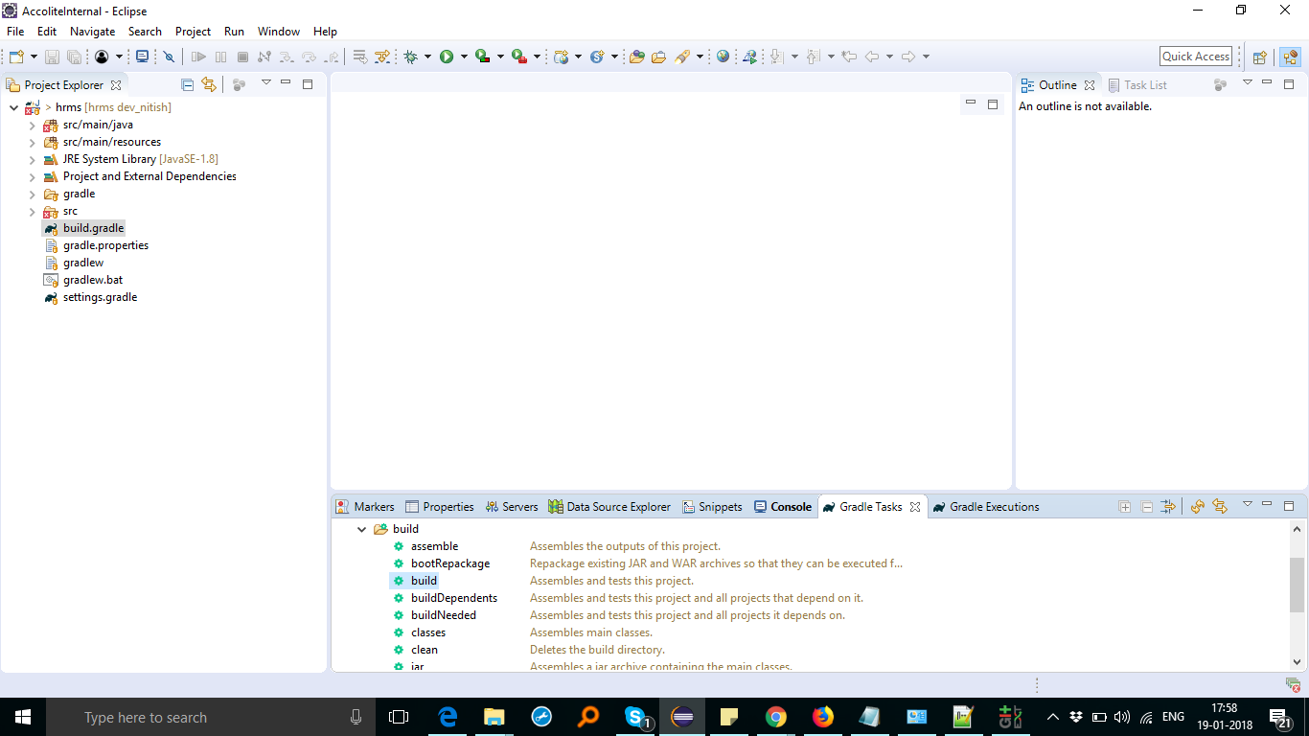

Try running the HRMSApplicationRunnr.java as an application:

